APPENDIX 6

TO THE PROCEDURE FOR

THE PURCHASE OF GOODS OR SERVICES BY

LS AIRPORT SERVICES S.A.

.

Request for Proposal

Inquiry on the presentation of the offer for supply and installation of racks for the storage of aircraft pallets for the needs of Ramp Handling Department in Warsaw.

LS Airport Services hereby invites you to participate in the procedure for supply and installation of rack for the storage of aircraft pallets for Ramp Handling Department in Warsaw.

We would like to inform that:

- the inquiry is not an invitation to tender under the Public Procurement Law (i.e. Journal of Laws 2017, item 1579, as amended), therefore we reserve the right to freely select the submitted offer;
- the bid selection procedure may be terminated at any time up to the day of signing the agreement without giving any reason, without selecting the Contractor, and the Contractor shall not be entitled to any claims against LS Airport Services S.A. on this account;
- Providing any of your own personal data constitutes your consent to their processing by LS Airport Services S.A. for the purposes of this procedure.

Submitting inquiry LS Airport Services S.A.

Having its principal office at: Warsaw (02-159), at 2b J. Gordon Bennett Street, entered into the register of entrepreneurs of the National Court Register maintained by the District Court for the capital city of Warsaw in Warsaw, XIV Commercial Division of the National Court Register, under the no 0000355602, tax identification number (NIP): 522-29-49-523, share capital PLN 40.440.020,00 paid in full, waste disposal database number (BDO): 000113178.
Pursuant to article 4c of the Act of 8 March 2013 on preventing excessive delays in commercial transactions (Journal of laws 2013, item 403/Dz.U. z 2013 r. poz. 403 as amended) LS Airport Services S.A. declares its status of a large entrepreneur within the meaning of article 4 point 6) of the abovementioned Act.
- Subject of the inquiry

The subject of the inquiry is the purchase with delivery and installation of racks in the Cargo Warehouse (LS Cargo Terminal, Wirażowa 35 Street, 02-158 Warsaw), according to the following specification:

- rack for storing empty airplane pallets together with necessary accessories (i.e. stops, pole and frame protection, other),
- Rack mounted outside the warehouse, exposed to weather conditions (partially roofed),
- Rack mounted to concrete ground. Legs at the base (one side) equipped with rollers allowing free movement by lifting the structure with a forklift from the other side.
- Support for loading PMC pallets on the rack with a forklift.
- Transverse skids on each storey to allow forklift forks to be inserted under the pallet stack, upper storey unroofed.

Type of pallets stored | PMC air pallet | PAJ air pallet
Pallet dimensions | 318 cm x 244 cm | 318 cm x 224 cm
Pallet weight | approx. 100 kg | approx. 90 kg
Max. Numer of stacked pallets (in the nest) | max. 15 pcs
Pallet stack heigt | approx. 60 cm
Method of loading pallets | With a forklift, pallets loaded individually
Pallet loading | From one side of the rack
Number of racks | 6 | 3
Number of slots | 18 | 9
Number of columns | 6 | 3
Number of levels | 3 | 3
First level at height | approx. 50 cm

Schematic drawing of the rack arrangement:

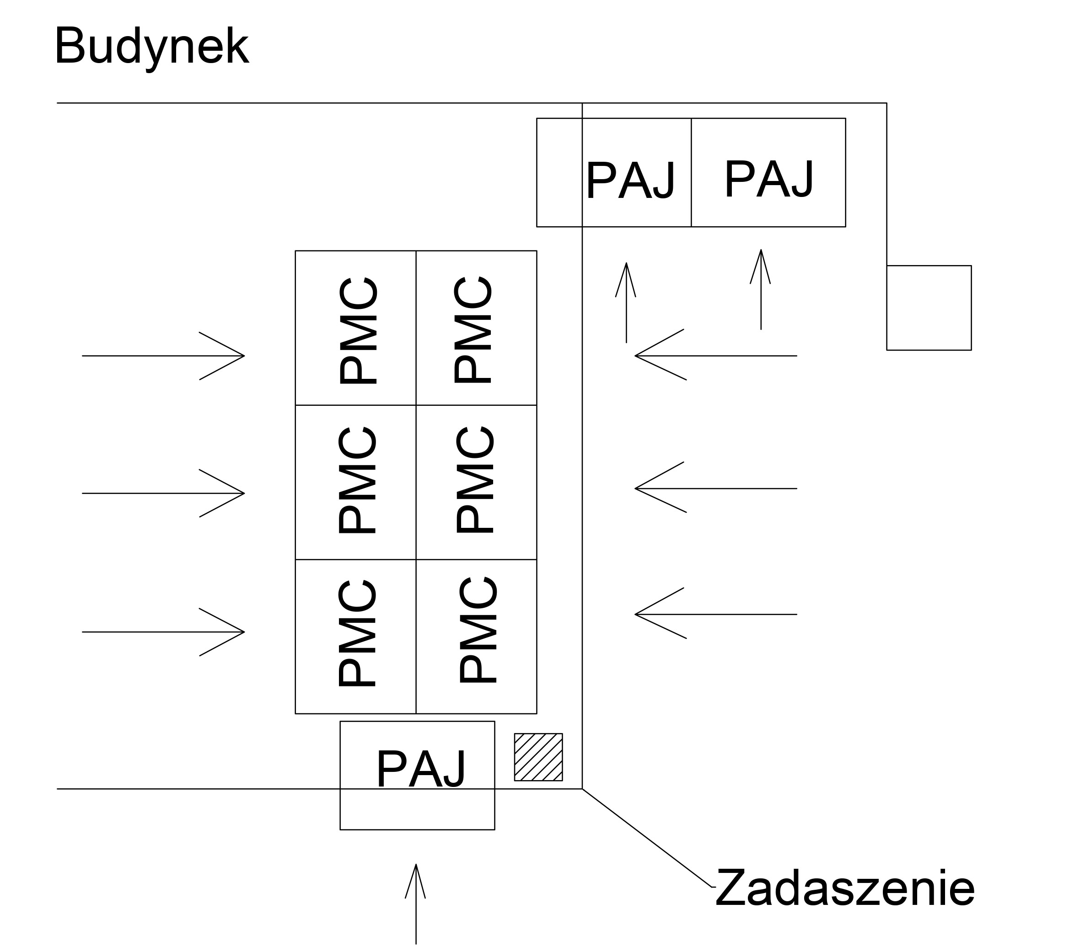
Zadaszenie/Roofing
Budynek/Building

It is a requirement to participate in a site visit to view the installation site. Submitting an offer will constitute acceptance of the place and conditions of assembly. The site inspection can take place at least one day in advance.

2. Place, date and method of submitting the response to the inquiry:
Please send the offer by post to the Company's address by February 28, 2022 at 16:00 p.m. in a sealed envelope with the note: "The offer for supply and installation of racks for the storage of aircraft pallets for Ramp Handling Department in Warsaw LS Airport Services S.A. - do not open"
addressed to :
Director Sebastian Kuna
LS Airport Services S.A.
Gordona Bennetta 2B Street, 02-159 Warsaw
Phone: (0 22) 206 95 00,
E-mail: sekretariat@lsas.aero
3. Contact regarding the inquiry
Information regarding the inquiry:
In commercial matters: Dorota Abramczyk
Mobile Phone: +48 887 831 122 e-mail: d.abramczyk@lsas.aero

Information regarding the inquiry:
Technical aspects: Wojciech Zborowski e-mail: w.zborowski@lsas.aero
Mobile Phone: +48 723 630 767

4. The method of preparing a response to an inquiry:
The method of preparing the response to the request for proposal is set out in the attachment to this request for proposal – ‘Request for proposal response form’.

The offer should include:
- Deadline for completion of the work
- Price conditions, and if the payment is to be made in parts, including on the basis of the advance payment, with a detailed description of what the payments depend on, i.e. on the implementation of part of the work according to the schedule, on the expiry of the deadline, etc.
- Confirmation of acceptance of the 30-day payment period.
- Offer validity period - minimum 45 days.
- Third party liability policy covering the subject of the offer - value min. 3 times the offer price, liability in tort and contract, PKD in accordance with the scope of works.
- Portfolio confirming the experience in similar realizations.
- Preliminary description of technology and works organization conditioning the Contracting Authority's obligations related to making the worksite and back-up facilities available to the Contractor.
- Warranty/guarantee terms for works and equipment with particular emphasis on exclusions of the Contractor's liability, i.e. what the Contractor does not accept liability for.
- Indication whether the Contractor intends to use subcontractors.
- Information on the method of protecting of the structure against corrosion due to atmospheric condition,
- Information on the estimated cost of review
- Technical drawings of the rack

Withdrawal from this criteria during contract negotiations may result in immediate rejection of the offer.

The formal requirements are:
- inclusion in the bid of the information listed above,
- participation in a site inspection before submitting the offer,
- Tenderer acting alone and not as part of a consortium,
- delivery of the offer within the stipulated deadline (the deadline of reception of the offer at the Company's registered office is decisive),
- the offer must be signed by a representative,
- sending the offer in the form of response to the request for quotation - the attachment to the request for quotation,
- enclosing to the offer signed statements of the potential contractor on confidentiality and personal data protection - forms attached,

5. Non-price relevant parameters:
- Warranty period
- Delivery time
- References - min. two similar orders for an Operators in the Cargo sector,
- Structural soundness as a result of making the racks from steel metallurgical profiles,]]

Attachments:
• Att. No 1 – REQUEST FOR PROPOSAL RESPONSE FORM;
• Att. No 2 – PERSONAL DATA INFORMATION CLAUSE GDPR (RODO)
• Att. No 3 – Declaration of a Contractor (confidentiality)
• Att. No 4 – Declaration of a potential Contractor (personal data protection).
• Att. No 5 – Schematic drawing of the rack arrangement
• Att. No 6 - Request for Proposal

